



SP92 Common Information Space
General and adaptor Information

Table of Contents

1. General information 3
2. Objectives of the document 3
3. Interoperability standardisation in Crisis and Disaster Management 4
4. The architecture of the Common Information Space 6
4.1 CIS adaptors architecture 6
4.1.1 CIS Connector 7
4.1.2 CIS Core 8
4.1.3 CIS Distributor 8
4.2 Sharing Information 9
4.3 CIS member and CGOR administration 10
5. CIS installation and configuration 11
5.1 CIS Adaptor Installation 11
5.2 CIS Adaptor Interfaces 11
5.2.1 CIS Adaptor Standalone 11
5.2.2 CIS Core Standalone 12
5.2.3 CIS integration into existing Application (only java supported at the moment) 12
5.3 CIS Adaptor Configuration 12
5.3.1 application.properties 12
5.3.2 config.properties 12

General information
Name of the meeting | SP92 Common Information Space
Type of document | Documentation
Document release date | 10.11.2017
Dissemination level of the document | Restricted (RE)
Related SP | SP92 - Test-bed
Authoring Partner Organisation | FRQ
Author of the document | Hannah Goeritz, Thomas Obritzhauser, FRQ

Objectives of the document
This document aims to describe the Common Information Space (CIS) in general. It is an attempt to clarify the architecture behind the CIS as well as its possible applications. While it can not be completely avoided to use technical terms in this kind of documentation, the document is primarly addressed to non-technicians. In addition to general information on the CIS this document will go into detail regarding a certain component of the CIS: the so-called CIS Adaptor. For the tool providers in the scope of the DRIVER+ project the CIS Adaptor is probably the most important component to understand of the CIS, as it has to be provided by each tool provider in order to allow communication and, most important, exchange of information between the tools.

First, the document will give a short overview of interoperability standards in the scope of crisis and disaster management. Afterwards, the architecture of the CIS, specifically of its Adaptor component is described in detail. It is specified how the exchange of information happens in the CIS and how the information is handled inside the adaptor. Later on, also the concept of CIS members and CGORs is explained. In the last section possible installations of the CIS Adaptor can be found as well as a description on how to install and configure the CIS Adaptor on your machine.

Interoperability standardisation in Crisis and Disaster Management
Standardisation of messages and their exchange is crucial to integrate different tools with each other. In other words, standards are the basis for syntactical interoperability. In the scope of DRIVER+ this interoperability plays a fundamental role. Therefore, standards have to be defined and acknowledged by all tool providers. In Crisis and Disaster Management there are already well-defined standards available that can be used for our purposes.
Every message content is packed in an Emergency Data Exchange Language Distribution Element (EDXL-DE) envelope that provides all parameters needed for the message routing, including data protection rules. The message content can be either a valid XML file or any mime type object (picture, text document, spreadsheet …) that the implemented adaptors can handle.
The CIS uses the following standards in the prototype and proof of concept (PoC), however, the CIS is not restricted to exactly these formats and protocols. Basically, the CIS architecture can handle any format that the adaptors provided by the partners have implemented.
- Common Alerting Protocol CAP: “CAP is a simple but general format for exchanging all-hazard emergency alerts and public warnings. CAP allows a consistent warning message to be disseminated simultaneously over many different warning systems, thus increasing warning effectiveness while simplifying the warning task. […] and CAP provides a template for effective warning messages based on best practices identified in academic research and real-world experience.”
The CAP standard definition allows to amend the defined data structure by individual parameters and to define customized CAP profiles.
- Mobile Location Protocol MLP: an application-level protocol for receiving the position of Mobile Stations (mobile phones, tablets, radio devices, etc.) independent of underlying network technology. In context of EPISECC CIS, MLP is used for reporting the location and the status of mobile devices of the responders in the field, and so for tracking of resources.
- Emergency Management Shared Information EMSI: used to transfer the situational view of an emergency as seen by an observer at a particular time to another observer, thus contributing to the situational awareness of the various parties regarding a given disaster or crisis event. The EMSI message follows an XML structure based on an object model. The main entities of this model are the following:
- Events: understood as something that takes place which an agency should respond to (e.g. a natural or man-made disaster),
- Resources: available to support or help in the response to the events, and
- Missions: aimed at handling the events and thus reducing their impact.
The objective of the EMSI specification is to ensure that the semantics of an individual message are unambiguous. A taxonomy of terms and hierarchical encoding to be used in the EMSI message is defined in the comprehensive EMSI data dictionary.

- Web Feature Service WFS/ Web Map Service WMS: WFS and WMS are both web service standards defined by the Open Geospatial Consortium (OGC). The main difference lies in the fact that while the WMS simply provides an image (raster tiles or vector format), i.e. the map itself, the WFS allows to request geographical features. Those features can then be manipulated and rendered by the client itself.

- Keyhole Markup Language KML/ Keyhole Markup Language Zipped KMZ: KML is a geographic information system format that is used to store spatial information, for example positions, polygons that describe an area and many others. KML files can be compressed for more efficient data exchange and handling. The compressed KML file is referred to as KMZ file.

This list can be extended if the concerned tools are able to process the corresponding information, e.g. by adding sensor data or information on missing persons.

The architecture of the Common Information Space
In this section, the architecture of the CIS and its components, in particular the CIS Adaptor, are described.
The idea of the CIS is based on the concept of Communication Groups Online Rooms (CGORs, see also subsection 4.3) and message distribution via the internet using Representational State Transfer (REST) services. For each tool that wants to share and/or receive information in the scope of the CIS a CIS Adaptor is mandatory. The CIS Adaptor is the connection between the CIS and the tool and is therefore specific for each tool. As a consequence, it must be implemented by the tool provider. To keep it as easy as possible, a template will be provided by the CIS product owner. In this way, tool providers are enabled to write their specific adaptors with minimized effort.
The following subsections describe the architecture and components of the CIS Adaptor, as well as the communication principles between them.

CIS adaptors architecture
The adaptors run within the secured network environment of the tool owner, also referred to as CIS member. Their proper functioning therefore lies in the tool owners responsibility.
Every adaptor consists of three components. First, a short overview of those components is given. The basic functions as well as the connections between the components can be also seen in Figure 1. Further below detailed component descriptions can be found.

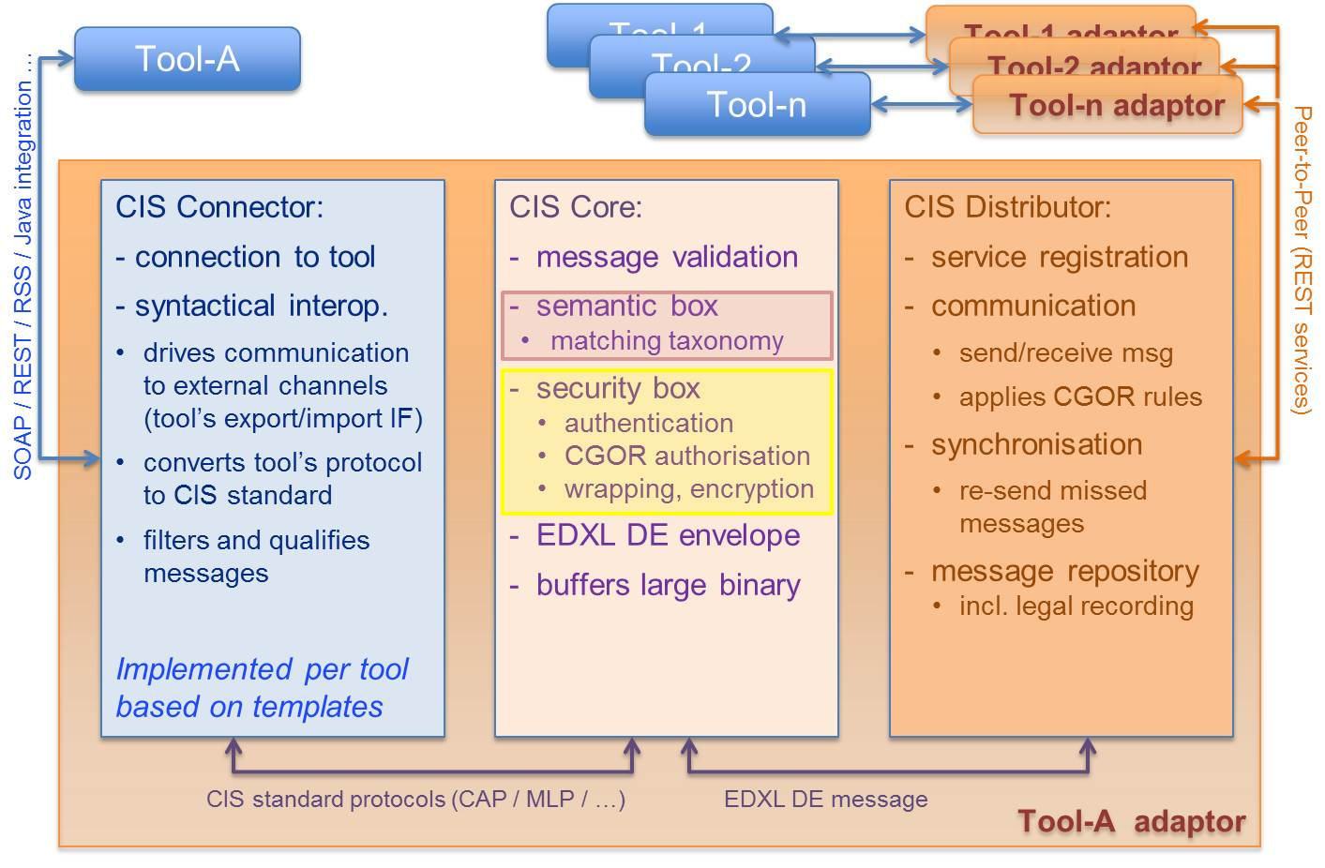
Figure 1: CIS Adaptor architecture

- CIS Connector: The CIS Connector represents the interface between a tool and the adaptor. It translates proprietary protocols to standards, and vice-versa. The Connector is the basically the part of the adaptor which is written by the tool provider based on the EPISECC Connector template.
- CIS Core: The CIS Core manages central functions in a uniform way. The application of security policy and the semantic matching is controlled by this component, to be precise by its Security and Semantic Services. Value added services can be integrated in the Core, which are then available to the whole system.
- CIS Distributor: The CIS Distributor represents the interface between the adaptor and the CIS. It manages the data exchange with the adaptors of other tools that are connected to the CIS.

CIS Connector
The CIS Connector handles the communication on the side of the tool – that means it covers all tool specific protocol and data handling implementations. Therefore, it has to be programmed and configured by the tool owner or manufacturer based on the adaptor template.

The following components and functions are provided by the template:
- The Network connectivity module receives messages from the tool as well as sends messages to the tool according to the used network protocol.
Currently the template provides a REST connection for message exchange.
The tool owner has to maintain network configuration tables with the addresses of the tool services to be connected.
- The Data format converter transfers proprietary data formats used by the tool to/from the standard messages that are exchanged in CIS (see also section 3). This step may be bypassed if the tool already uses the appropriate standard.
- The Standard translator replaces proprietary key values and enumerations by standardized ones and vice versa, based on translation tables which have to be provided by the tool owner. This applies only for code value sets mandatorily listed in the standard definition (e.g. CAP status, msgType, category …) to form a correct standard message.
Note: Do not confuse this with the semantic annotations provided by the Semantic Box (see subsection 4.1.2.1) which are based on mapped taxonomies.
- The EDXL DE generator assembles the parameters for the EDXL DE that envelops all messages distributed in CIS. The template will provide a minimum set of default values that might be extended by the developer of the CIS connector. For example, security related parameters can be added dependent on the message content.
- The Connector also provides filtering of received messages based on EDXL DE parameters.
Currently available filters are based on the ‘msg type’ parameter.
Filters might be extended by the developer of the CIS connector also based on the message content.
- Logging, for debugging purposes only.

CIS Core
As already mentioned, the CIS Core is provided by the CIS Product Owner and therefore can not be modified by the CIS members. It takes care of managing the central CIS features, partly based on the EDXL DE and CIS specific parameters transferred:
- Authentication assures that incoming messages originate from a trusted partner application, according to the service registration.
- Authorization services control the flow of information and protect sensitive data from unauthorized access. Appropriate encryption mechanisms are defined and implemented in the CGOR concept (see also subsection 4.3).
- Validation of the transferred messages assures the formal correctness and application of standards. Improperly formatted messages will be rejected.
- The EDXL DE Wrapper packs the information into an EDXL DE envelope.

Additional Core functions which were not implemented yet could be:
- Object Buffer function stores large binary objects (message attachments) in an accessible store (e.g. FTP server) and replaces them by the URI in the message.
- Value Added Services (optional plug-ins) may make use of the transferred information e.g. for message logging, auditing, reporting or statistics.

Semantic Box
Another component of the CIS Core is the so-called Semantic Box.
The role of the Semantic Box in the CIS prototype consists in translating concepts (words) between sender’s and recipient’s taxonomy (official set of words used by responders). The link between two concepts from distinct taxonomies is called a semantic relation. As the concept of semantic translation is currently not part of the DRIVER+ project, the Semantic Box will not be described in detail in the scope of this document.

CIS Distributor
The CIS Distributor is the interface between an Adaptor and the CIS or between several adapters connected via the CIS, respectively. The distribution of messages in the CIS is based on Apache Kafka.
- There are two REST interfaces: one responsible for sending messages and another one for receiving them.
- Messages can be sent to either one or several members of the same CGOR at a time.
- The sender’s Distributor accepts an EDXL-DE-wrapped message from its CIS Core and addresses it individually to any recipient distributor.
- The receiving Distributor acknowledges the reception of the EDXL-DE message regardless of their ability to process the content of the message as the sender does not care if the recipient fails to process the message once it is delivered.
- Each sent and/or received message is stored in a database handled at distribution level only. This message storage database was implemented in case a synchronization mechanism will be added for previously lost messages (e.g. because a connected receiving tool was offline).

Sharing Information
The following sequence diagrams in Figure 2 and Figure 3 visualize the flow of information between the CIS Adaptor components.
The interface to the tool is individual and must be implemented in the Connector. Currently a REST – based communication is provided by the template, but it may also be Java integration or any other interface technology. The internal connections between all other components are implemented as REST services.

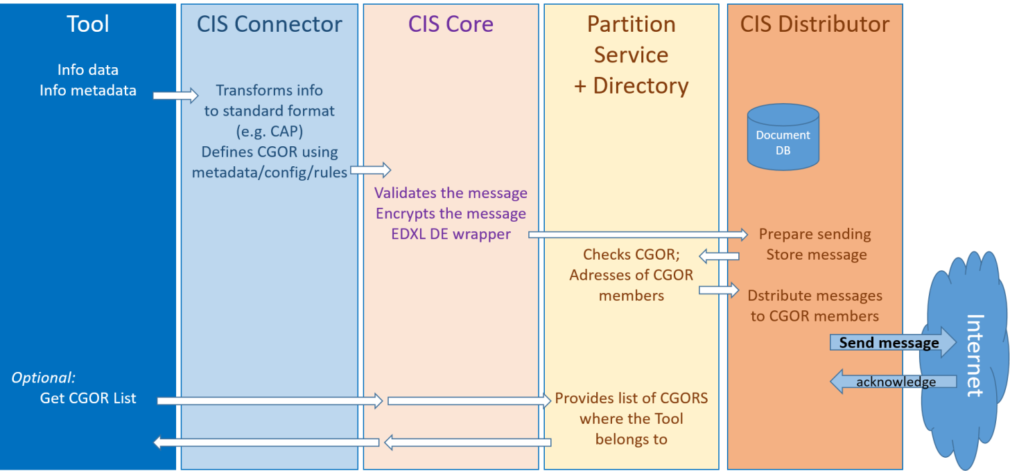
Figure 2: Sending information to CIS

The Core must define the CGOR where the message is addressed to. This can be implemented using static parameters in a configuration file, or dynamically by a rule engine evaluating information metadata or content. In the specific case of tools supporting the CIS distribution feature, the CGOR can also be defined by the tool user.

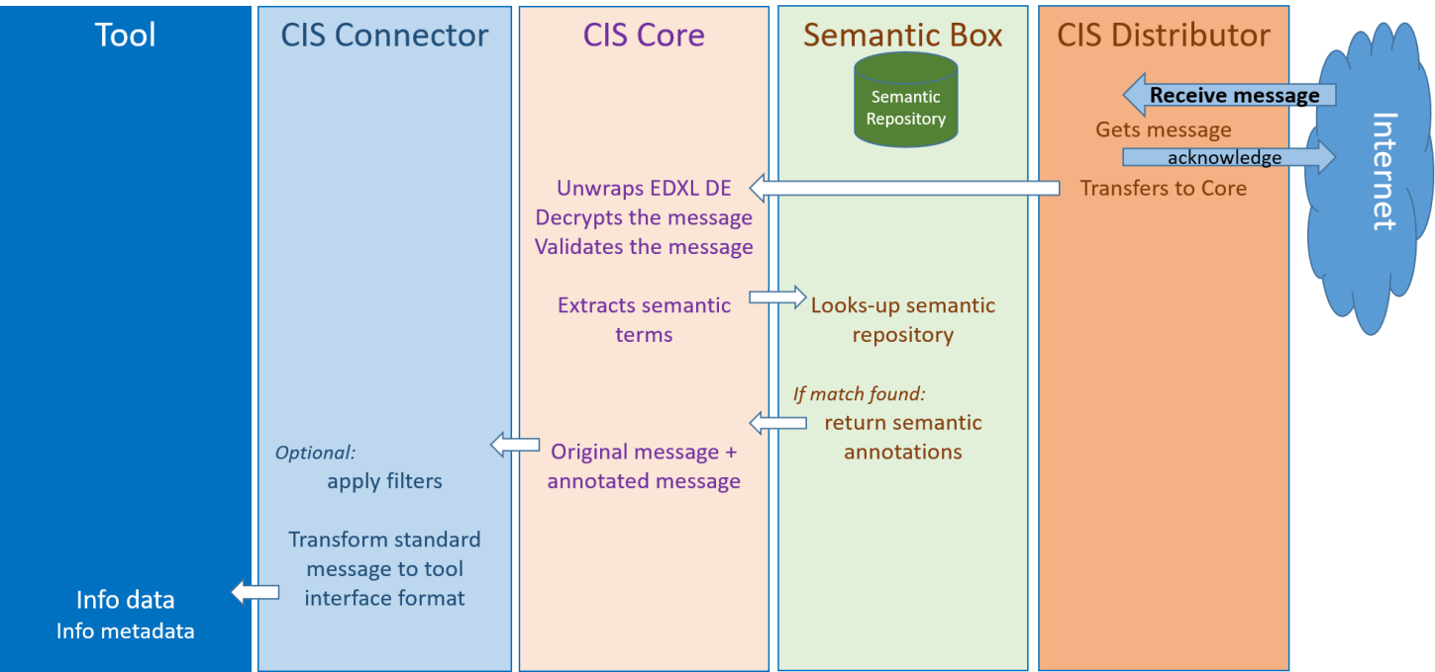
Figure 3: Receiving information from CIS
When a message is received from the CIS, the distributor forwards the EDXL-DE message to its associated CIS Core for processing. As already mentioned, the Semantic Box, while being part of EPISECC, is currently not used in DRIVER+.
The Connector must be programmed in a way to handle the transmitted information appropriately so that the tool can use them. This information handling can also include filtering dependent on message content or EDXL DE parameters set by the sender. Amending the standards used in CIS, message profiles (defined sets or values of standard parameters) may be agreed upon between the CIS participants.

CIS member and CGOR administration
Existing emergency management tools do not include the concept of Communication Groups Online Rooms (CGORs) for dynamic group building, therefore an additional administration service is provided. The administration interface is based on a client web application for configuring the CIS-Adaptors. Its purpose is to establish and manage the CGORs for tools, which have no dedicated feature implemented to manage CGORs themselves.
CGORs are similar to emailing lists. They serve as sub-groups composed of CIS-participants, who exclusively share information between a subgroup of stakeholders involved in crisis- and disaster management. These subgroups are involved in the management of one specific incident or recurring types of emergencies/events. This fact concludes that the organisations have to be in a list of stakeholders of the CIS during the preparation phase, therefore before any emergency event happens. After the event occurs, CIS participants can create CGORs and invite other participants to share information on this specific CGOR (a specific mission or a specific event). When a CGOR is created, a distribution list (like a mailing list) of all the CGOR-members is created and maintained by the CGOR creator, who has the administration rights for this CGOR. This list is updated in case a new member is added or a member is removed. The distributor component of the CIS-adaptor enforces the access rights of the CGOR. For every dedicated CGOR, the Distributor has a list of the CGOR-members and distributes the information only to the list members.

CIS installation and configuration

CIS Adaptor Installation
The CIS Adaptor(s) are available as a zipped package that contains everything to run the Adaptor. The software itself is an executable jar which contains an embedded tomcat for exposing the REST Endpoints to/from the Application and to/from the CIS Distributor. The CIS Adaptor needs an installed JDK 8 on the machine where it is to be executed.

CIS Adaptor Interfaces
The interfaces are defined as depicted in Figure 4. As one can see, communication inside the Adaptor is based solely on REST services. While the Core is always provided by the CIS product owner, also the connector might be used as stand-alone component together with the core (see sub-section 5.2.1).
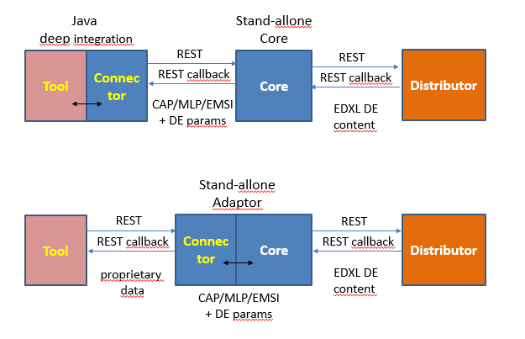
Figure 4: Communication interfaces between adaptor components

CIS Adaptor Standalone
The CIS Adaptor Standalone executable is a general base Adaptor implementations that handles already standard based message for exchange. For tool specific translation (in the connector), the Adaptor Standalone has to be changed to use a tool specific connector that handles the data translation.
The CIS Adaptor standalone can be started by the included start script: startCISAdaptor.bat
For testing the Adaptor provides a swagger-interface which provides possibility to thest all relevant Interfaces of the Adaptor.
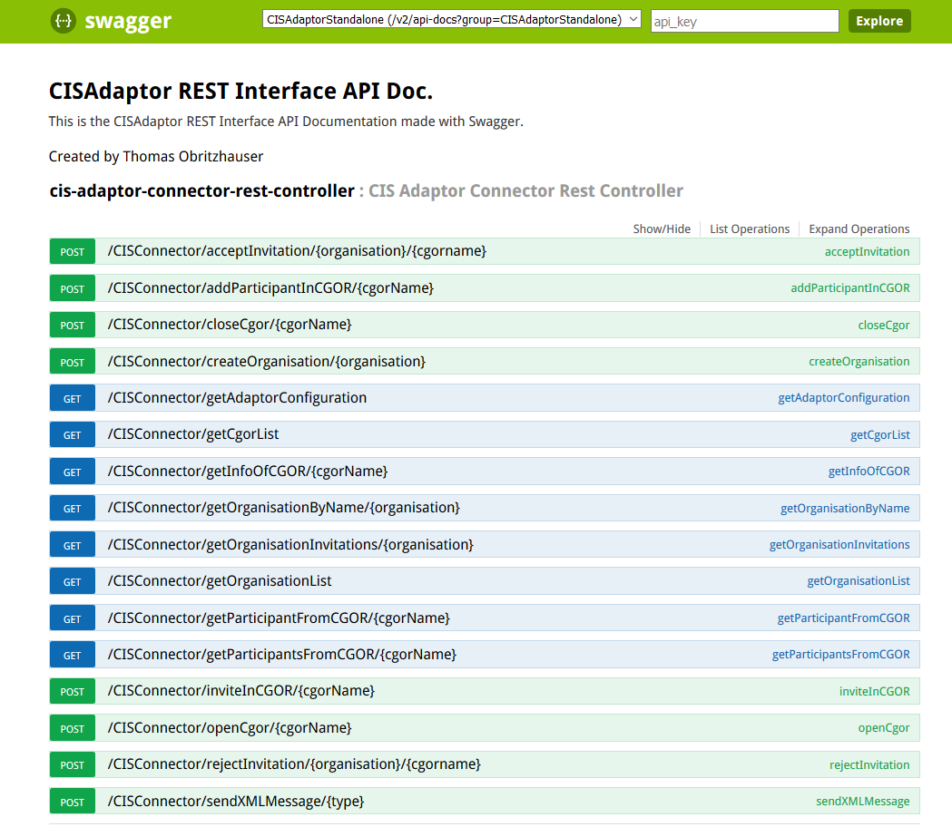

CIS Core Standalone
t.b.d

CIS integration into existing Application (only java supported at the moment)
t.b.d

CIS Adaptor Configuration
The Adaptor needs to know some predefined data that are provided by properties files, located in the config directory which is also part of the Adaptor zip file.
Note: Configuration changes are only recognized during the Adaptor startup sequence.

application.properties
#the port on which the tomcat is listening
server.port=8081

config.properties
Following configurations need to be done / defined:
#path to the schema for message validation
edxlde.schema.location=./schema/edxlde/edxl-de-v2.0-wd11.xsd
core.edxlde.validate=true

#ignore errors on startup (only for testing)
startup.ignore.error=false

#Distribution config
#can be FILE, KAFKA, LB
# FILE: compose EDSL DE message will be written into the /message directors in the root directory of the adaptor
# KAFKA:EDXL DE messae is going to be distributzed via the KAFKA instance
# LB: Loopback - EDXL DE will be redirected to the adaptor core distributor callback interface
distribution.env=KAFKA

#the default communication group online room to which the data will be sent
cgor.default.name=driver

#The Organisation name for which die Adaptor is configured
cis.org.name=DRIVER

#Loopback distributor REST Endpoint (for testing without Distributor)
distributor.lb.host=localhost
distributor.lb.port=8180
distributor.lb.path=core/CISConnector/postmessage

#The Application callback to which the message content is sent
application.callback.rest.endpoint=http://localhost:8180/core/CISConnector/testendpoint
#define if you want to send the original message of enveloped
application.callback.send.orig=false
#Kafka configuration

#The server under which the the distributing service is available
distributor.kafka.host=driver-service.ait.ac.at

#The server port
distributor.kafka.port=9092

#The topic to which the consumer should subscribe itself to. Needs to be shared across all connected clients
# DRIVER-EXP
distributor.kafka.topic=DRIVER-TEST

#The consumer's groupId. This value should not be changed until further notice
distributor.kafka.groupId=driverGroupId

#Distributor configuration

#This flag decides whether messages that are sent to the Kafka server should also be processed as if it was a new message
#If it is set to false the EDXL-DE sender ID of the incomming message is checked it matches the configured SenderID
#If they match the incomming message is discarded
distributor.receiveOwnMessages=false

